RDM Installation

1. Install the packing from “\\brandt\itguy\Repo\Help Desk\Software\Remote Desktop Manager (Devolutions)\” using typical settings.
2. Once completed launch the Remote Desktop Manager.
3. Click on File in the top left corner
4. Click on Data Sources

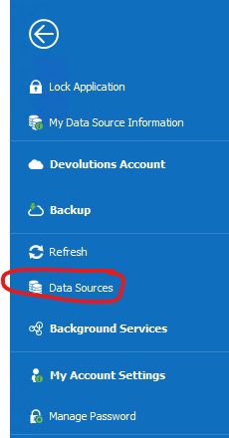

1. Click the “Plus” symbol to create a new data source.

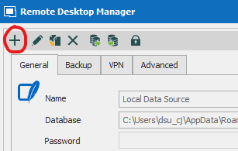

1. Choose “Devolutions Server”

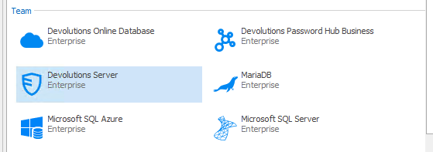

1. Use the following settings then click OK.

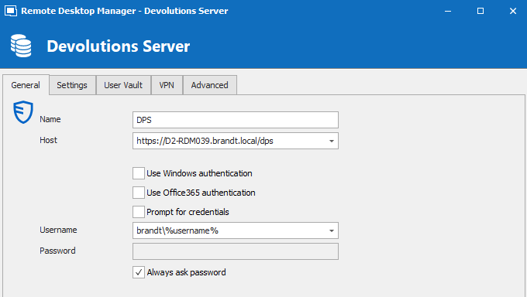

1. Remove the “Local Data Source” by selecting it then clicking the X in the top left of the window by the +.

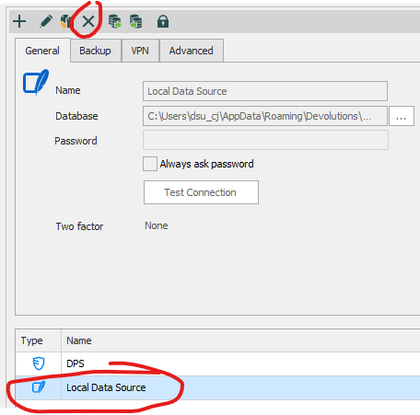

1. Click OK.
2. Login with your DSU account.
3. Click the back arrow to return to the app.
4. Done.